**Web Programming – CS4032**

**Assignment 01 PART B**

**Name: Razeen Shahid**

**Roll Number: 21F-9224**

**Section: BSCS-6B**

**Course Instructor: Muhammad Hannan Farooq**

TASK 01:

HTML:

<!DOCTYPE html>

<html>

<head>

<title>Razeen Shahid's Webpage</title>

<link rel="stylesheet" href="style1.css">

</head>

<body style="background-color: blue;">

<div class="Intro">

<h1 style="font-size: 36px;">Name: Razeen Shahid</h1>

<h3>Roll Number: 21F-9224</h3>

<h4>About Me:</h4>

<p> A highly motivated Computer Science student capable of meeting tight deadlines, seeking a challenging data analyst position. I have experience in programming, statistical analysis, and data visualization to provide valuable business insights.

</p>

</div>

</body>

</html>

CSS:

.Intro{

color: rgb(218, 232, 232);

text-shadow: 4px rgb(240, 31, 31);

}

OUTPUTS:

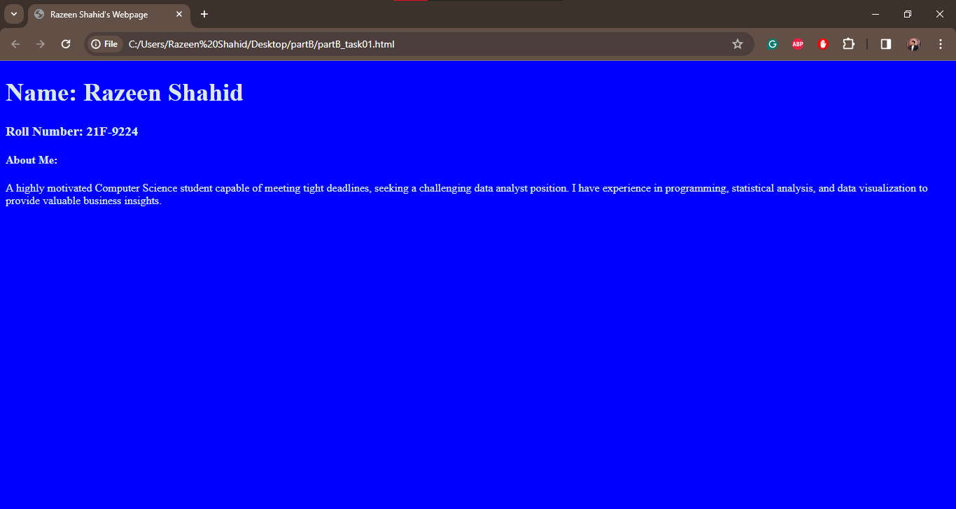

TASK 02:

HTML:

<!DOCTYPE html>

<html>

<head>

<title>Razeen Shahid's Webpage</title>

<link rel="stylesheet" href="style2.css">

</head>

<body>

<div class="detail">

<h1>Start CSS Exercises</h1>

<h5>Good luck!</h5>

<div class="btn">

<button class="btntext" >Start CSS Exercise ></button>

</div>

</div>

</body>

</html>

CSS:

.detail{

background-color: rgba(0, 0, 0, 0.755);

box-shadow: 2px 6px 10px 2px rgba(0,0,0,0.2);

color:aliceblue;

padding-top: 2px;

padding-left: 8px;

padding-bottom: 10px;

border-radius: 8px;

width: 20cm;

font-family:'Times New Roman', Times, serif;}

.btntext{

color:aliceblue;

background-color: green;

padding: 16px;

border-radius: 6px;

font-size: small;

font-family: 'Gill Sans', 'Gill Sans MT', Calibri, 'Trebuchet MS', sans-serif;

}

OUTPUTS:

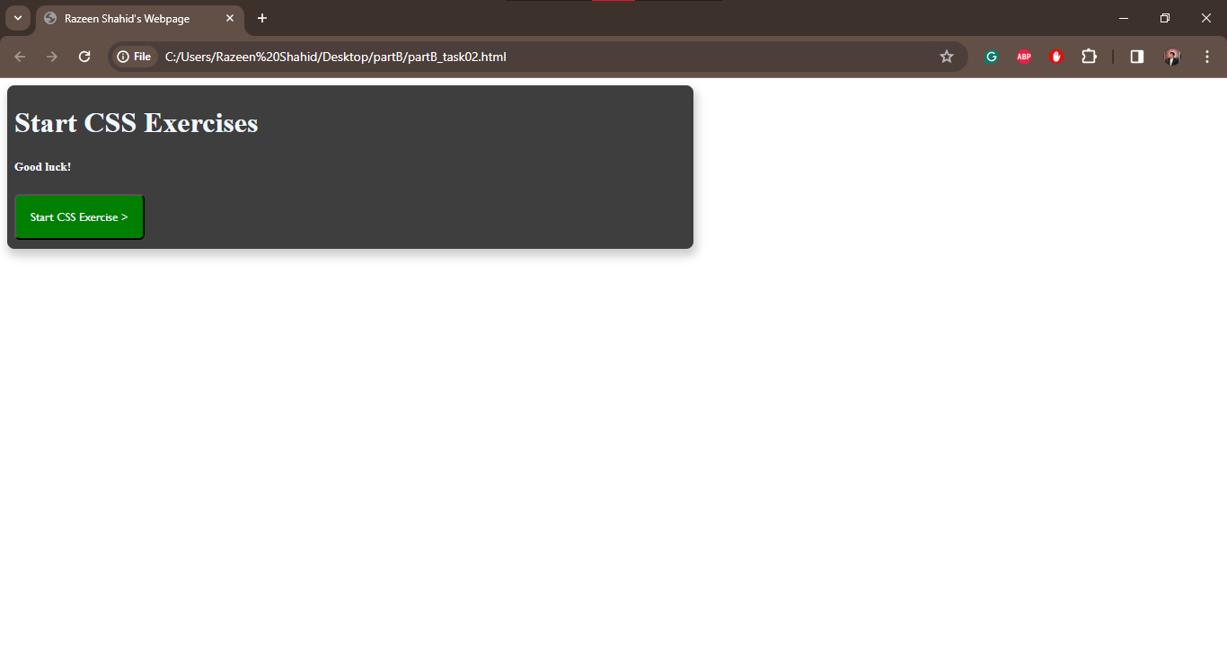

TASK 03:

HTML:

<!DOCTYPE html>

<html>

<head>

<title>Razeen Shahid's Webpage</title>

<link rel="stylesheet" href="style3.css">

</head>

<body>

<div class="signupform">

<h2 id="heading"><b>Contact Us</b></h2>

<div class="container">

<form action="" method="get">

<label id="namelabel" for="name">Your Name</label>

<br>

<input id='name'type="text" placeholder="Razeen Shahid">

<br><br>

<label id="emaillabel" for="email">Your Email</label>

<br>

<input id='email'type="email" placeholder="hello@example.com ">

<br><br>

<label id="pnlabel" for="phonenumber">Your Phone Number</label>

<br>

<input id='phonenumber'type="text" placeholder="Format 123-456-7890" format="(0-9)(0-9)(0-9)-(0-9)(0-9)(0-9)-(0-9)(0-9)(0-9)">

<br><br>

<label id="msglabel" for="message">Your Message</label>

<br>

<input id='message' rows="4" type="textarea" placeholder="Type your message here...">

<br> <br>

<button class="submitbtn">Submit</button>

<br> <br>

<button class="resetbtn">Reset</button>

</form>

</div>

</div>

</body>

</html>

CSS:

#heading{font-family: 'Segoe UI', Tahoma, Geneva, Verdana, sans-serif;}

.signupform{

width:fit-content;

letter-spacing: normal;

text-align: center;

display: grid;

display:block;

box-shadow: 2px 8px 10px 2px rgba(0,0,0,0.2);

transition: 0.3s;

margin-left:15cm;

padding-top: 15px;

}

.signupform:hover {

box-shadow: 2px 10px 18px 2px rgba(0,0,0,0.2);

}

.container {

margin: 40px;

padding: 10px 14px;

}

#namelabel{

padding-right: 25mm;

}

#emaillabel{

padding-right: 25mm;

}

#pnlabel{

padding-right: 9mm;

}

#msglabel{

padding-right: 20mm;

}

.submitbtn{

margin-right: 2mm;

padding-left: 58px;

padding-right: 58px;

text-align: center;

font-size: medium;

font-style:normal;

font-family: 'Times New Roman', Times, serif;

background-color: rgb(134, 185, 58);

color:rgba(255, 255, 255, 0.937);

}

.resetbtn{

margin-right: 3mm;

padding-left: 63px;

padding-right: 65px;

margin-left:1mm;

text-align: center;

background-color: rgb(134, 185, 58);

font-size: medium;

font-style:normal;

font-family: 'Times New Roman', Times, serif;

color:azure;

}

#name{

border: 0.5px solid;

margin-top: 1mm;

border-bottom-left-radius: 5%;

border-bottom-right-radius: 5%;

border-top-left-radius: 5%;

border-top-right-radius: 5%;

}

#email{

border: 0.5px solid;

border-bottom-left-radius: 5%;

border-bottom-right-radius: 5%;

border-top-left-radius: 5%;

border-top-right-radius: 5%;

margin-top: 1mm;

}

#phonenumber{

border: 0.5px solid;

margin-top: 1mm;

border-bottom-left-radius: 5%;

border-bottom-right-radius: 5%;

border-top-left-radius: 5%;

border-top-right-radius: 5%;

}

#message{

border: 0.5px solid;

margin-top: 1mm;

border-bottom-left-radius: 5%;

border-bottom-right-radius: 5%;

border-top-left-radius: 5%;

border-top-right-radius: 5%;

}

OUTPUTS:

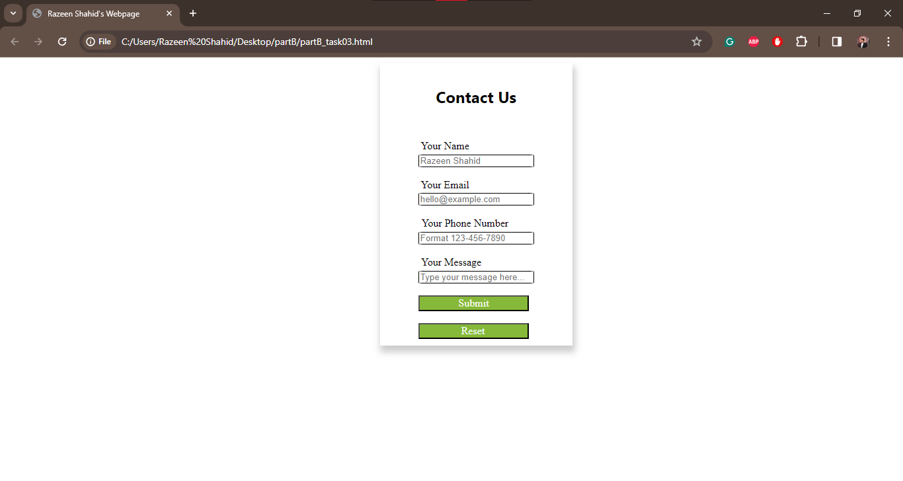

TASK 04:

HTML:

<!DOCTYPE html>

<html>

<head>

<title>Razeen Shahid's Webpage</title>

<link rel="stylesheet" href="style4.css">

</head>

<body>

<div class="card" >

<img src="picture04.jpg" alt="Scenery">

<div class="container">

<h2> Nature Scenery Image </h2>

</div>

</div>

</body>

</html>

CSS:

.card{

box-shadow: 2px 6px 10px 2px rgba(0,0,0,0.2);

width: fit-content;

margin-left: 80mm ;

margin-top: 20mm;

transition: 0.3s;

}

.card:hover{

box-shadow: 2px 6px 10px 18px rgba(0,0,0,0.2);

}

.container{

background-color: aliceblue;

text-align: center;

padding: 2mm;

font-size: medium;

font-family: 'Franklin Gothic Medium', 'Arial Narrow', Arial, sans-serif;

}

OUTPUTS:

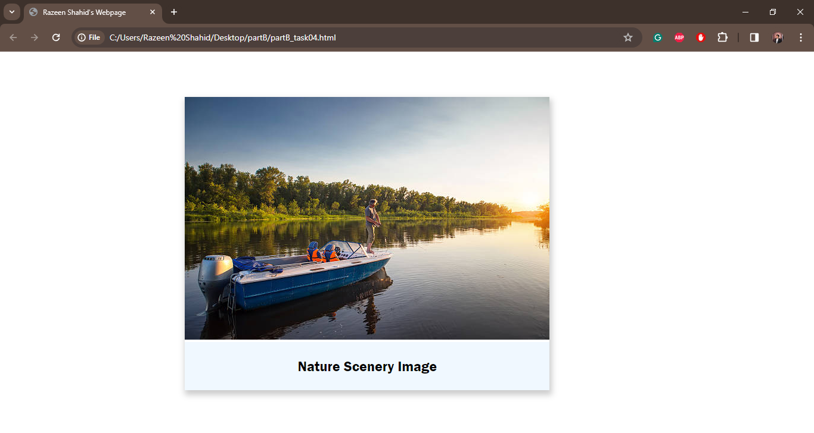

TASK 05:

HTML:

<!DOCTYPE html>

<html>

<head>

<title>Razeen Shahid's Portfolio</title>

<link rel="stylesheet" href="style5.css">

</head>

<body>

<section class="headers">

<div class="Name"><h1>Razeen Shahid</h1></div>

<div class="profession"><h2>Data Analyst</h2></div>

<div class="container"><img class="mypic" src="IMG_2845.jpg" alt="mypic"></div>

<div class="links">

<div>

<img class="linkedin" src="linkeninlogo.jpg" alt="linkedin">

<a href="https://www.linkedin.com/in/razeen-shahid-8b685a223/"><span class="linkedinlink"><b>Linked In</b></span></a>

<img class="github" src="gitlogo.jpg" alt="github">

<a href="https://github.com/razeen-shahid"><span class="githublink"><b>Github</b></span></a>

<img class="email" src="emaillogo.jpg" alt="email">

<span class="emailid"><b>razeenshahid@mail.com</b></span>

</div>

</div>

</section>

<section class="aboutme">

<h3 class="tagline" >About Me </h3>

<p>

A highly motivated Computer Science student capable of meeting tight deadlines, seeking a challenging data analyst position. I have experience in programming, statistical analysis, and data visualization to provide valuable business insights.

</p>

</section>

<section class="personalinfo">

<h3>Personal Information</h3>

<ul>

<li><b>Date of Birth:</b> August 30,2001</li>

<li><b>Nationality:</b>Pakistani</li>

<li><b>Address:</b>Lahore, Pakistan</li>

<li><b>Email:</b>shahidrazeen@mail.com</li>

<li><b>Phone:</b>+92-308-4187792</li>

</ul>

</section>

<section class="education">

<h3>Education</h3>

<ul>

<li><b>Degree:</b>BSc. Computer Science</li>

<li><b>Institution:</b>FAST-NUCES</li>

<li><b>Graduation Year:</b>June-2025</li>

</ul>

</section>

<section class="workexperience">

<h3>Work Experience</h3>

<ul>

<li><b>Job Title:</b>Data Analyst</li>

<li><b>Company:</b>Aesthetix PK</li>

<li><b>Duration:</b>Nov 2022 – Dec 2023</li>

<li><b>Responsiblities:</b>Apply predictive analysis and tools to datasets to help forecast various business metrics and scenarios</li>

</ul>

</section>

<section class="projects">

<h3>My Projects</h3>

<div class='content'>

<h4>Pakistan Toshakhana Data Analysis [MS Excel | SQL | Power BI]</h4>

<p>Description of Project: • Utilized Power BI to conduct analysis on the case to identify trends, patterns, and connections between the expensive cars and gifts that former Pakistani government officials received from international heads of state and dignitaries. </p>

<button class="vdbtn">View Details <span class="arrowhead">></span></button>

</div>

<div class="morecontent">

<h4>Revenue Insights of a Clothing Brand [Power BI | MS Excel | Python]</h4>

<p>Description of Project: • Created Power BI dashboard, the Revenue Team of the Brand were able to gain insights about their revenue trend. This could help in regaining their profit and market share by 20% in the next month. </p>

<button class="vdbtn2">View Details <span class="arrowhead2">></span></button>

</div>

</section>

<section class="skills">

<h3>Skills</h3>

<ul>

<li><b>Machine Learning</b></li>

<li><b>Python/R</b></li>

<li><b>Power BI | MS Excel</b></li>

<li><b>Predictive Analysis</b></li>

</ul>

</section>

<footer >

<h3>You can contact me at: <b>shahidrazeen@mail.com</b></h3>

</footer>

</body>

</html>

CSS:

body{

background-color: rgb(228, 225, 225);

}

.headers{

background-color: rgb(97, 96, 96);

box-shadow: 0px 0px 0px black;

}

.Name{

text-align: center;

padding-top: 8mm;

margin-right: 15mm;

color: aliceblue;

}

.headers:hover{

box-shadow: 5px 6px 16px black;

transition: 1s;

}

.mypic{

text-align: center;

width: 50mm;

height: 52mm;

border-radius: 5%;

margin-bottom: 5mm;

}

.container{

text-align: center;

margin-left: 130mm;

margin-top: -30mm;

display: block;

}

.profession{

text-align: center;

margin-right: 15mm;

color: aliceblue;

}

.linkedin{

width: 5mm;

height: 5mm;

background: none;

border-color: black;

mix-blend-mode:lighten;

border-radius: 5px;

margin-left: 160mm;

}

.linkedinlink{color: aliceblue;}

.github{

width: 5mm;

height: 5mm;

background: none;

border-color: black;

border-radius: 5px;

margin-left: 10mm;

}

.githublink{color: aliceblue;}

.email{

width: 5mm;

height: 5mm;

background: none;

border-color: black;

mix-blend-mode:lighten;

border-radius: 5px;

margin-left: 10mm;

}

.emailid{color: aliceblue;}

.aboutme{

width: fit-content;

background-color: azure;

padding-left:10mm ;

padding-right: 55mm ;

margin-left: 8mm;

padding-top: 10mm;

padding-bottom: 10mm;

margin-top: 10mm;

}

.aboutme:hover{

transition: 0.5s;

padding-right: 70mm;

margin-left: -1mm;

padding-top: -2mm;

}

.personalinfo{

width: 322mm;

background-color: azure;

padding-left:10mm ;

padding-right: 55mm ;

margin-left: 8mm;

padding-top: 10mm;

padding-bottom: 10mm;

margin-top: 10mm;

}

.personalinfo:hover{

transition: 0.5s;

padding-right: 70mm;

margin-left: -1mm;

padding-top: -2mm;

}

.education{

width: 322mm;

background-color: azure;

padding-left:10mm ;

padding-right: 55mm ;

margin-left: 8mm;

padding-top: 10mm;

padding-bottom: 10mm;

margin-top: 10mm;

}

.education:hover{

transition: 0.5s;

padding-right: 70mm;

margin-left: -1mm;

padding-top: -2mm;

}

.workexperience{

width: 322mm;

background-color: azure;

padding-left:10mm ;

padding-right: 55mm ;

margin-left: 8mm;

padding-top: 10mm;

padding-bottom: 10mm;

margin-top: 10mm;

}

.workexperience:hover{

transition: 0.5s;

padding-right: 70mm;

margin-left: -1mm;

padding-top: -2mm;

}

.projects{

width: 322mm;

background-color: azure;

padding-left:10mm ;

padding-right: 55mm ;

margin-left: 8mm;

padding-top: 10mm;

padding-bottom: 10mm;

margin-top: 10mm;

}

.morecontent {

display: none;

}

.projects:hover .morecontent {

display: block;

}

.projects:hover{

transition: 0.5s;

padding-right: 70mm;

margin-left: -1mm;

padding-top: -2mm;

}

.vdbtn{

background-color: rgb(50, 50, 234);

color:white;

padding: 2mm;

border-radius: 6%;

}

.arrowhead{

padding-left: 0.5mm;

text-align: center;

visibility: hidden;

padding-left: 2mm;

}

.vdbtn:hover{

padding-right: 6mm;

transition: 0.3s;

margin-left: -1mm;

padding-top: -2mm;

}

.vdbtn:hover .arrowhead{

visibility: visible;

}

.vdbtn2{

background-color: rgb(50, 50, 234);

color:white;

padding: 2mm;

border-radius: 6%;

}

.arrowhead2{

padding-left: 0.5mm;

text-align: center;

visibility: hidden;

padding-left: 2mm;

}

.vdbtn2:hover{

padding-right: 6mm;

transition: 0.3s;

margin-left: -1mm;

padding-top: -2mm;

}

.vdbtn2:hover .arrowhead2{

visibility: visible;

}

.skills{

width: 322mm;

background-color: azure;

padding-left:10mm ;

padding-right: 55mm ;

margin-left: 8mm;

padding-top: 10mm;

padding-bottom: 10mm;

margin-top: 10mm;

}

.skills:hover{

transition: 0.5s;

padding-right: 70mm;

margin-left: -1mm;

padding-top: -2mm;

}

footer{

background-color: rgb(60, 129, 175);

box-shadow: 0px 0px 0px black;

margin: 6mm;

margin-left: 8mm;

text-align: center;

color: aliceblue;

padding: 3mm;

}

OUTPUTS:

